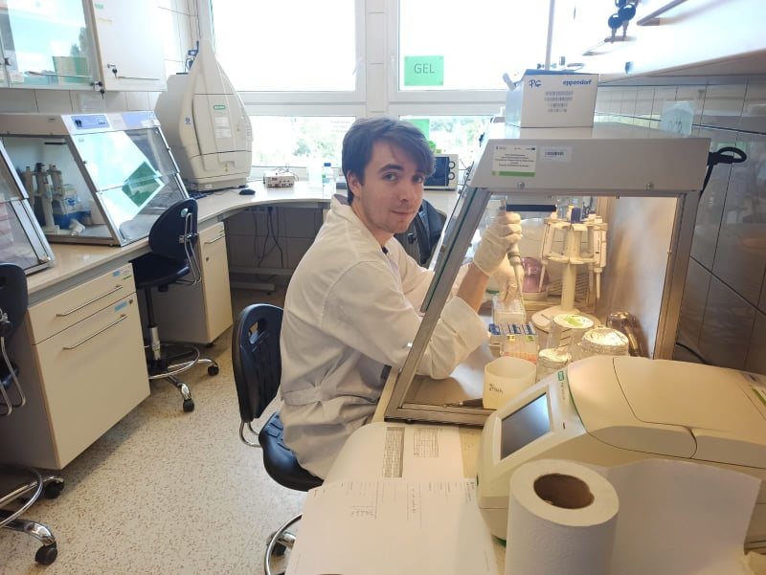
This summer I was lucky enough to secure a research placement at the University of Lodz in Lodz, Poland. My supervisor – Dr. Piotr Gadawski and I performed a study to assess the genetic diversity of local Chironomidae populations in the High Tatra Mountains. By using metabarcoding technique we are aiming to examine local gene flow. Moreover, since it was the first time such a study was conducted on this community, we hope we will be able to find new cryptic species. Metabarcoding is especially crucial for studying populations of Chironomidae since with classic identifying techniques.
For the first part of my research I prepared and run DNA extraction from already conserved sampled. I used Chelex 100 method, since it both performed well when it comes to DNA extraction success rate and preserved the samples for possible future analysis. First, I run a trial run to check if the method will work well for the given samples. 14 out of 16 trial samples did positively in further PCR run. After the trial run I used the same techniques for all of my samples.
Then, I had to perform PCR run for every sample to prepare them for further DNA sequencing. The success of those runs had to been confirmed by the agarose gel electrophoresis run. In general I performed PCR and agarose gel electrophoresis on 704 samples and obtained 586 good quality samples, which then were send for the DNA sequencing. DNA sequencing was performed by the outside company so, unfortunately, I was not able to perform it myself.
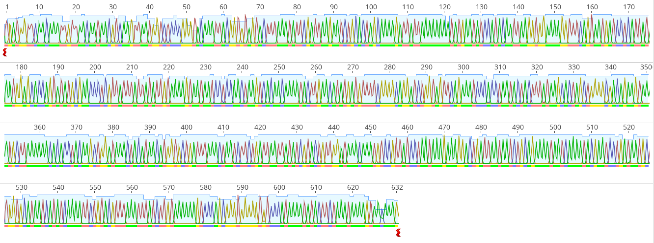
Next, I performed a general analysis of the collected data in DNA sequencing software. It is worth mentioning, that I am still working as a part of this research group on that project, so I’m still gaining experience, especially in the bioinformatics area. As for now, I edited sequences to upload them in the barcodes sequences.
This experience mainly thought me the laboratory practises and techniques. By working with 704 samples I learned how to manage huge amount of samples and keep track of them in my laboratory records. I am sure, that such an experience prepared me better to run laboratory work in my future academic career.
Additionally, I got familiar with common laboratory methods like DNA extraction, PCR, and agarose gel electrophoresis. Since they are not only used for metagenomic studies, but for variety of different biology areas I can confidently find myself in the laboratory based work after my experience. Going forward I will be better prepared to secure a laboratory based work or run it myself.
Moreover, my supervisor and I are planning to publish our results in the near future. Hence, thanks to Rokos Award I will be able to achieve a publication in the foreseeable future, that will highly improve my chance to secure a job as a scientist.

