Netted Carpet Moth Survey at Muncaster Castle
2021 Rokos Report
Barbara Francik

This summer I was lucky enough to work on a Netted carpet moth (Eustroma reticulatum) surveying project for Muncaster Estate, Cumbria. Muncaster Castle had been last surveyed for the moth in 2015, but its population, and that of its foodplant, were deemed to be declining at the time. The aim of this project was to identify whether viable populations still existed at Muncaster Castle, and to produce an Action Plan for their conservation.
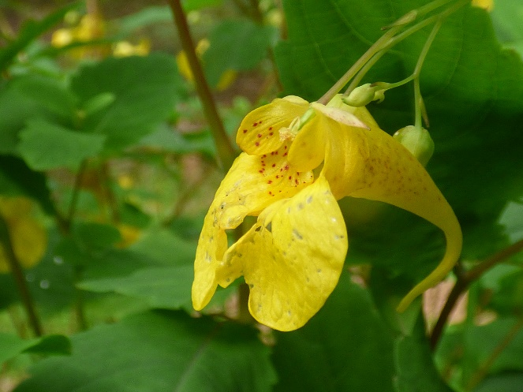
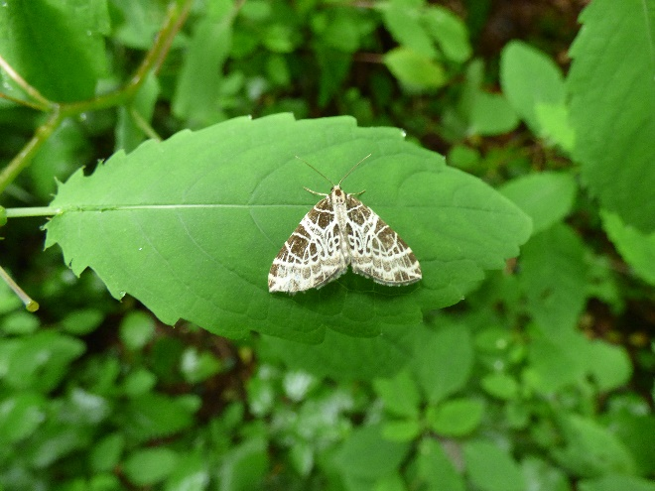
The Netted carpet moth is one of the UK’s rarest Lepidopterans, and it is essentially limited in its range to the Lake District. It only has one foodplant – the annual Touch-me-not Balsam (Impatiens noli-tangere). This is the only native British species of balsam, and is itself considered scarce. The plant requires very specific conditions, growing only in disturbed, damp, nutrient-rich soil which is subject to dappled shade and free from other plants. It has no long-term seedbank, and its populations are subject to huge local fluctuations, and sometimes rapid disappearances from one year to the next. The loss of many large grazers, including the extinct aurochs, and lack of cattle grazing in forested areas, means that there are relatively few areas disturbed enough for balsam to take root. Human forestry operations now provide a significant foothold for it.
Adult Netted carpet moth on Touch-me-not balsam
Before starting the internship, I conducted a lot of research into how the moth has been surveyed in the past. I contacted researchers from Reading University and the National Trust who had worked with the moth in the past to learn about their methods. I also studied the balsam and the moth’s caterpillars, which I would be counting, to ensure I
Touch-me-not balsam flower
knew where to look and how to identify them.

The internship itself was split into two main parts. First, I spent about two weeks in July-August scouring the 77-acre estate for patches of balsam. Once these were located, I conducted a larval survey of the Netted carpet moth in September. Parallel to this, I also set up light traps around the estate to record overall moth biodiversity.
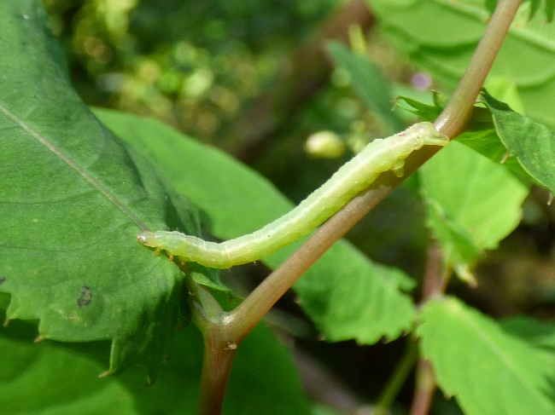
Looking for the balsam was sometimes tricky. A lot of the patches were easy to locate as they tended to grow along paths or where forestry work had recently been carried out. However, several patches were located off the main paths, and a lot of potential balsam sites were simply located in the middle of forested areas. Battling through giant nettles and huge brambles was a very regular part of my day. During these explorations, I discovered that binoculars can be surprisingly good for locating plants, not just animals! In the end, I recorded 20 balsam patches, which totalled to about 2330 individual plants.
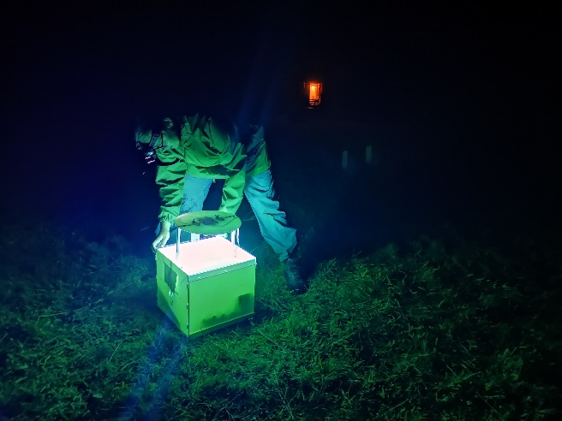
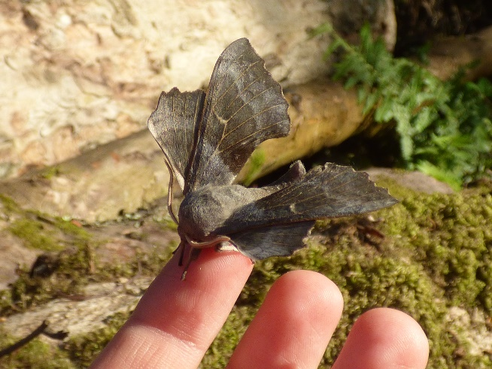
In September, when the Netted carpet caterpillars were almost mature and large enough to spot easily, I conducted the larval survey. This involved returning to each of the patches I had identified earlier and carefully searching as many plants as possible for caterpillars. The caterpillars tended to hide on the undersides of leaves or along stems, mimicking closely the balsam’s long, explosive seed pods. The main difficulty was the fact that a very similar species, the Small phoenix (Ecliptopera silaceata) was common on the estate and also had caterpillars which fed on balsam. As both the Netted carpet and the Small phoenix are Geometrid moths with green larvae, and unique colour patterns are only visible on very mature caterpillars, there is a significant risk of confusion. Fortunately, the two species can be distinguished by their mouthparts: in the Netted carpet they are forward-facing, whilst in the Small phoenix they are downward-facing. A hand lens was absolutely necessary. Overall, 151 caterpillars were located across 1481 plants checked. I estimated there to be about 265 caterpillars on the entire estate, based on their densities in different balsam patches.
Setting up a moth trap
Netted carpet moth caterpillar on balsam
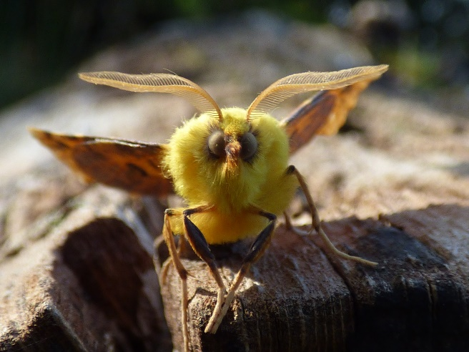
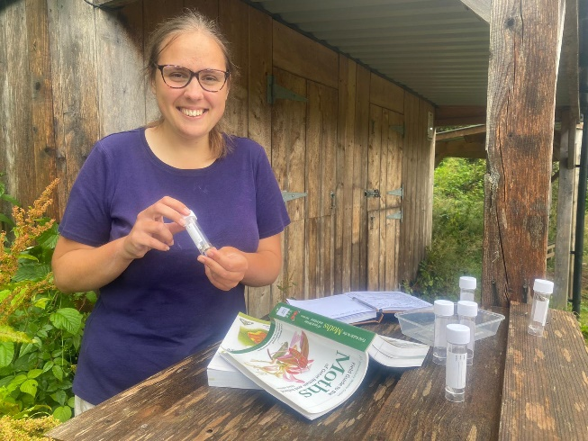
Besides the Netted carpet moth survey, I also conducted a general moth survey at Muncaster. I had two moth traps up, one mains-powered and one portable battery-powered. These were both non-lethal light traps, which work similar to lobster pots in that they lure moths through a funnel into a box, from which it is very difficult to escape. Although the Netted carpet moth itself is not particularly attracted to light, I did manage to catch one adult near a balsam patch. It was an extremely exciting moment when it was identified. The sheer diversity of moths was also staggering – the UK has 896 species of macro-moths and 1627 species of micro-moths. In comparison, there are only 59 UK butterfly species. At Muncaster, I manged to distinguish over 135 species of moths. Many of these were very colourful and large. One of the most impressive was the Poplar hawk-moth, which has a wingspan of about 8cm. Besides moth traps, I also used sweep nets and beating sheets to catch and identify other moth caterpillars.
Canary-shouldered thorn (Ennomos alniaria)
Poplar hawk-moth (Laothoe populi)
Throughout the surveying process, I worked closely with the staff at Muncaster, particularly those working in forestry and gardening, education and the Hawk and Owl Centre (many of whom were very enthusiastic about moths!). They were extremely friendly and helpful. I also consulted regularly with researchers from Reading University and the National Trust, joining them on one of their own Lake District surveys to find out more about conservation methods being employed at other sites.
Identifying moths from the traps. There is an adult Netted carpet moth inside the tube!

I used the data from the balsam and Netted carpet moth larval counts to produce a report for Muncaster outlining the current population status of both plant and moth. Both had increased significantly since the last survey in 2015. The moth was now present at high densities and appeared to have a healthy population. The balsam had also rebounded, although given the transient nature of this annual plant and the small size of some of the patches, it is still not an entirely stable population. In the Action Plan, I made recommendations on how existing patches of balsam could be preserved and expanded for the moth. These included disturbing the soil in winter, once the balsam had died back, and the removal of encroaching perennials such as nettles. I also advised on how to create new balsam patches by making suitable conditions and spreading locally collected seeds. Finally, I produced a set of guidelines on how to conduct future surveys, and the role that volunteers could play in this.
Overall, I found this internship experience extremely enriching. It has reaffirmed my desire to do research which requires fieldwork. I feel I have learned a lot about how to independently plan and carry out a biological investigation, as well as analyse my own data and make real-world recommendations based on my findings. One of the most valuable aspects of this internship was learning how to network with people, including the staff at Muncaster but also the researchers who helped me whilst planning and carrying out these surveys. I would like to thank them all for the amazing work and support they provided. I would also like to thank the Rokos Foundation and Santander for the funding which made all of this possible.

