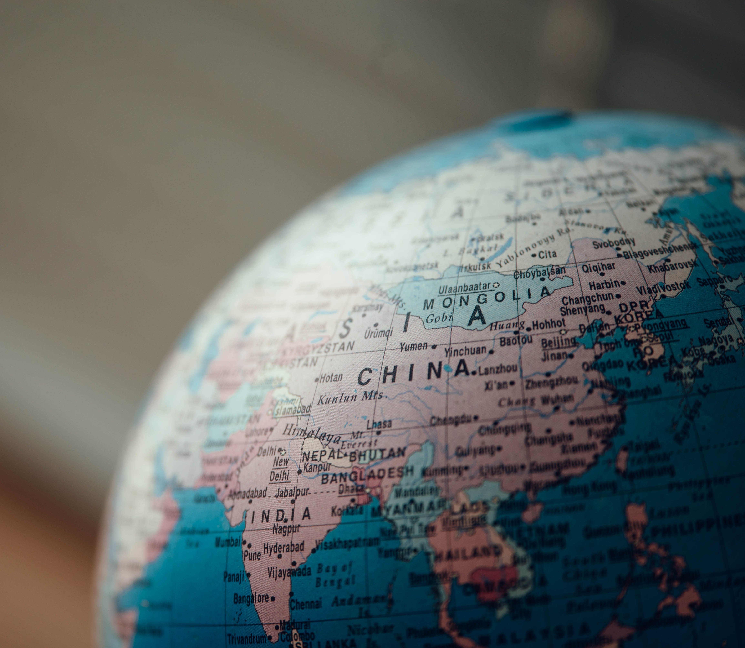

Books, History, News, and Films on China
Helpful resources for those considering a degree in Chinese
2022

History
Patricia Buckley Ebrey and Kwang-Ching Liu, The Cambridge Illustrated History of China Cambridge: Cambridge University Press, 1999.
Patricia Buckley Ebrey, Chinese Civilization: A Sourcebook. Any edition.
Lloyd E. Eastman, Family, Fields and Ancestors: Constancy and Change in China’s Social and Economic History. Oxford: Oxford University Press, 1988.
Valerie Hansen, The Open Empire: A History of China to 1600. New York: Norton, 2000/
Jonathan D. Spence, The Gate of Heavenly Peace: The Chinese and their Revolution, 1895-1980. Harmondsworth: Penguin Books, 1987.
Timothy Brook. Vermeer’s Hat: The Seventeenth Century and the Dawn of the Global World. London: Bloomsbury Press, 2008.
Tsu, Jing. Kingdom of Characters: A Tale of Language, Obsession and Genius in Modern China. London: Allen Lane, 2022.
Craig Clunas. Art in China. Oxford: Oxford University Press, 1997.
Patricia Buckley Ebrey, A Visual Sourcebook of Chinese Civilisation. https://depts.washington.edu/chinaciv/
MIT Visualising Cultures. http://ocw.mit.edu/ans7870/21f/21f.027/home/index.html

Politics and News

NYT China https://www.nytimes.com/topic/destination/china
Up-to-date commentary and analysis

Reuters News Agency http://www.reuters.com/places/china

All-round news source for China, especially for business, economics and politics. The articles headed “Insight” are particularly useful.

Financial Times – China https://www.ft.com/stream/8b82f4f1-6fdf-4fe1-91db-99cac1802016
News, commentary, and analysis on politics, economics, and other topics on China.

China File http://www.chinafile.com

Online magazine run by the Center for US-China Relations and the Asia Society, edited by Orville Schell, big-name analysts. Also includes good links to other major China stories on the web.

Asia Dialogue http://theasiadialogue.com/
Hosted by the University of Nottingham but with external contributions, great source of commentary and analysis.

China Media Project http://chinamediaproject.org/
Online magazine run by Qian Gang and David Bandurski in partnership with the University of Hong Kong, focusing on politics, media, and communications.

Carnegie Tsinghua https://carnegietsinghua.org/
Beijing chapter of the Carnegie Endowment. Great analysis on politics, international relations, and law.

Jamestown China Brief https://jamestown.org/programs/cb/
China analysis for policy-makers, intelligence and military personnel, academics, journalists, and business leaders under the direction of Dr. Arthur Waldron at the University of Pennsylvania.

MERICS – Mercator Institute for China Studies https://www.merics.org/en
Berlin-based think tank working on China’s political, economic, social, technological and ecological developments, and the corresponding global impacts. It has a particular focus on China’s impact on Europe.

SupChina https://supchina.com/
Along with its widely known Sinica podcast, this is a must-know resource on Chinese news, social trends, and their analysis.

Nikkei Asian Review https://asia.nikkei.com/
Provides a view from Japan and often offers analysis and insights unavailable elsewhere.

What’s on Weibo https://www.whatsonweibo.com/
Managed by Manya Koetse. The site focuses on social trends on the Chinese social media platform Weibo and provides accompanying analysis and context.

Richard McGregor. The Party: The Secret World of China’s Communist Rulers. New York: Harper Collins. 2010.
Kerry Brown. CEO, China : The Rise of Xi Jinping. IB Tauris, 2016.

Classical Literature and Philosophy
Confucius, The Analects. Translated by D.C.Lau. Harmondsworth: Penguin, 1979. (Any edition)
Cao Xueqin, The Story of the Stone, Translated by David C. Hawkes. 5 vols. Harmondsworth: Penguin, 1973-1986.
Pu, Songling. Strange Tales from a Chinese Studio. Translated by John Minford. London : Penguin, 2006.

Modern Literature
Eileen Chang (Zhang Ailing), Lust, Caution. Harmondsworth: Penguin, 2007.
Eileen Chang (Zhang Ailing), Love in a Fallen City. Harmondsworth: Penguin, 2007.
Han Han. 1988: I Want to Talk with the World. Seattle: Amazon Crossing, 2015.
Hu Fayun. Such is This World@sars.come. Dobbs Ferry: Ragged Banner Press, 2011.
Jiang Rong. Wolf Totem. Harmondsworth: Penguin, 2008.
Lao She, Rickshaw Boy. New York: Harper Perennial, 2010.
Lu Xun, The Real Story of Ah Q and Other Tales of China. Harmondsworth: Penguin, 2009.
Shen Congwen, Imperfect Paradise: Stories by Shen Congwen. Honolulu: Hawaii University Press, 1995.
Yan Lianke. Serve the People!. London: Constable, 2007.
Yu Hua. Brothers. New York: Anchor, 2010.
Zhu Wen. I Love Dollars and Other Stories of China. New York: Columbia University Press, 2006.

Film
Hou Hsiao-hsien, The Puppetmaster, 1994.
Jia Zhangke, Still Life, 2006
Lu Chuan, City of Life and Death, 2009.
Tian Zhuangzhuang, The Blue Kite, 1993.
Tsai Ming-liang, The River, 1997.
Wong Kar-Wai, Chungking Express, 1994.
____________, In the Mood for Love, 2000.
Edward Yang, Yiyi: A One and a Two, 2000.
Zhang Yimou, Hero, 2001.

Biographies and Memoirs
Pang-Mei Natasha Chang, Bound Feet and Western Dress. London: Bantam Books, 1996.
Hsieh Ping-ying, Autobiography of a Chinese Girl, 1943. (Any edition)
Edgar Snow, Red Star over China, 1938 (Any edition).
Yue Daiyun and Carolyn Wakeman, To the Storm: the Odyssey of a Revolutionary Chinese Woman. Berkeley: University of California Press, 1985.
Jung Chang, Wild Swans: Three Daughters of China. 1991. (Any edition)
Liang Heng, Son of the Revolution, 1983. (Any edition)
Nien Cheng, Life and Death in Shanghai, 1986. (Any edition)
Rae Yang, The Spider Eaters: A Memoir, 1997. (Any edition)
Guo Yue, Music, Food, and Love, 2005. (Any edition)

People’s Experiences
Meyer, Michael. The Last Days of Old Beijing: Life in the Vanishing Backstreets of a City Transformed. New York: Walker & Co. 2008.
Wolf, Margery. The House of Lim: A Study of a Chinese Farm Family. New York: Appleton-Century-Crofts. 1968.
Jie Li, Shanghai Homes: Palimpsests of Private Life. New York: Columbia University Press, 2014.
Dautcher, Jay. Down a Narrow Road: Identity and Masculinity in a Uyghur Community in Xinjiang, China. Cambridge: Cambridge University Press. 2009.
Zheng, Tiantian. Red Lights: The Lives of Sex Workers in Postsocialist China. Minneapolis: University of Minnesota Press. 2009.
Osburg, John. Anxious Wealth: Money and Morality among China’s New Rich. Stanford: Stanford University Press. 2013.
Johnson, Ian. The Souls of China: The Return of Religion after Mao. Alfred A. Knopf, 2017.
Osnos, Evan. Age of Ambition : Chasing Fortune, Truth and Faith in the New China. Vintage, 2015.
From Mao to Mozart – Isaac Stern in China, 1979 (film) https://youtu.be/1JtXq63b-Fw

Chinese Language Resources (for those who haven’t studied the language before)
There's a website called Chinesefor.us which has a series of really basic free lessons https://chinesefor.us/free-chinese-lessons-videos/ which you might start off with.
It also has good instructions for learning to write the Chinese characters in the correct way which is really important for the Oxford course ("stroke order" is important for our exams):
Learn Chinese Characters for Beginners Easy Fast and Fun
https://www.youtube.com/watch?v=oqfsxCxrzh4&list=PLWXyZU_NJb_e-WehXnNDYm7GwoXUmqoks
There are loads of other materials available online, so don't worry if these don't suit, just hunt around for something else you enjoy more.

