Akshar Foundation Internship Travel Report
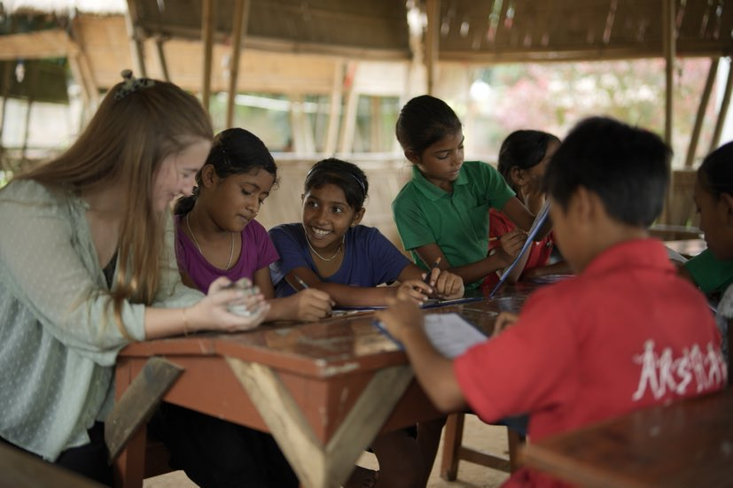
This Summer, I was very lucky to travel to Assam, India with the help of the George Bredin Travel Prize and the George Bredin Travel Fund. While there, I completed a six-week internship with an NGO named Akshar Foundation, based in Guwahati. I worked as a junior teacher, teaching English, Maths and Science. I also organised a ‘science show’, which used basic household items to demonstrate interesting scientific phenomena.
I found this internship on the Oxford Careers Service’s Summer Internship Programme. I originally applied for the Summer 2021 internship, but unfortunately this was cancelled due to the Covid-19 pandemic. My place was carried over and I was given the opportunity to do the internship in Summer 2022 instead. The Akshar Foundation aims to revolutionise the Indian education system. It’s education model is targeted at eradicating child labour and increasing social mobility. The Akshar Foundation’s education model combines conventional academic subjects (Maths, Science, English) with vocational teaching such as carpentry, farming and entrepreneurship, thus embodying Mahatma Gandhi’s Nai Thalim education philosophy. What, in my opinion, is the most revolutionary policy that Akshar has adopted, is employing older students to teach younger students. Each day, there is a short session dedicated to ‘match-up’, where older students are paid to deliver one-to-one tuition to younger students. Of course, this helps the younger student learn more quickly, but it also helps the older student to take responsibility and hone their leadership skills. Most of all though, this prevents the older students from dropping out of school and going to work, thus preventing child labour. After successfully trialling this system in their model school, Akshar have been given authority to work in 100 government schools throughout Assam. It is early days, and Akshar are currently working in 4 government schools.
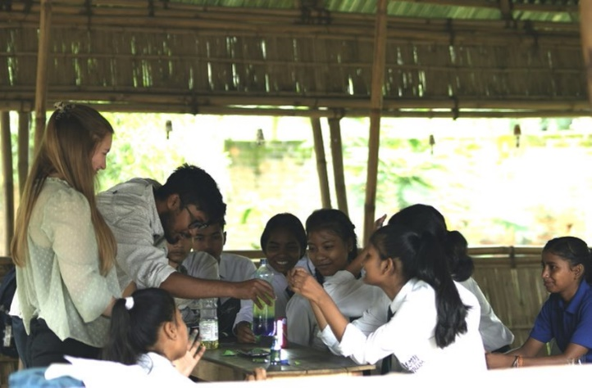
The first week after I arrived was full of new experiences: incredible street food, cows wondering the streets, and lush green landscapes. Compared to the rest of India, Assam is a relatively cool, wet region. Nevertheless, Assam is hot and humid compared to the UK. This took some getting used to. We spent the first week being shown around the different schools that Akshar are working in. This involved greeting many students who were very excited to meet us. I also spent the first week planning my science project: I needed to work out which experiments I would teach the students, which materials I would need, and how much they would all cost. The experiments included making a ‘lava lamp’, a Non-Newtonian fluid, and a ‘tornado’. The plan was to spend time teaching these experiments in each school, and then all of this would culminate in a science exhibition at the end of the internship.
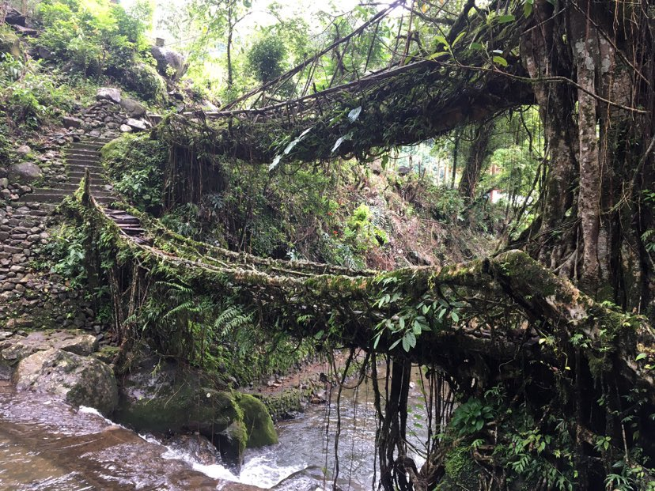
As the weeks went by, I became more accustomed to teaching and communicating with the students. Most of the science experiments had gone well, although we ended up only teaching in two schools: the model school and one government school. This was because Akshar were still trying to establish their education model at the other government schools, and weren’t as far along this process as they had hoped to be. We also spent some time meeting officials, helping to expand Akshar’s reach. We met with USTM and IIT, two universities in India. We also met some donors of Akshar Foundation and some people working at the Assam Legislative Assembly.
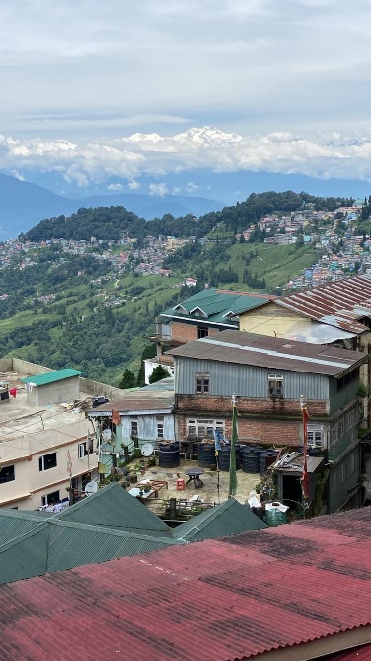
We spent most weekends sightseeing. We went to Shillong, Cherrapunji and Darjeeling. Shillong (locally known as ‘Scotland of the East’, thanks to its cooler climate), is a very compacted, busy city, a few hours’ drive south from Guwahati. Cherrapunji is home to some of the best views I have ever witnessed. Huge green ridges fill the landscape, and when the sun rises from behind them, it is spectacular. We hiked to see the living root bridges – bridges consisting only of roots, developed by local people over decades. Along this hike and elsewhere in Cherrapunji, we saw some beautiful waterfalls. Towards the end of the trip, we visited Darjeeling. This required a long train and taxi ride but was well worth it. We could see the Himalayas, standing majestically in the distance. The markets, food and views in Darjeeling were fantastic.
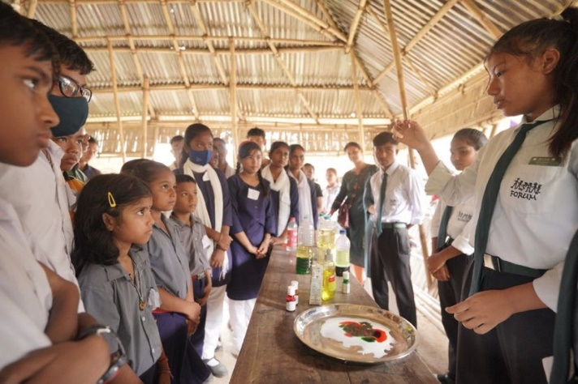
By the end of the internship, it was time for the science exhibition, which had turned into more of a ‘science show’ by this point. The students demonstrated the experiments, explaining the science behind each of them with the use of posters they had made in the previous weeks. This was a very successful event. It was combined with the other interns’ projects: a badminton tournament, a plastic recycling presentation and a robotics demonstration.
I was very lucky to have been able to take part in this internship. It taught me leadership skills and built my confidence. I was given the opportunity to travel around India, and hopefully help to solve the child labour problem in a tiny way.

